**AWS VPC**

**VPC Creation**

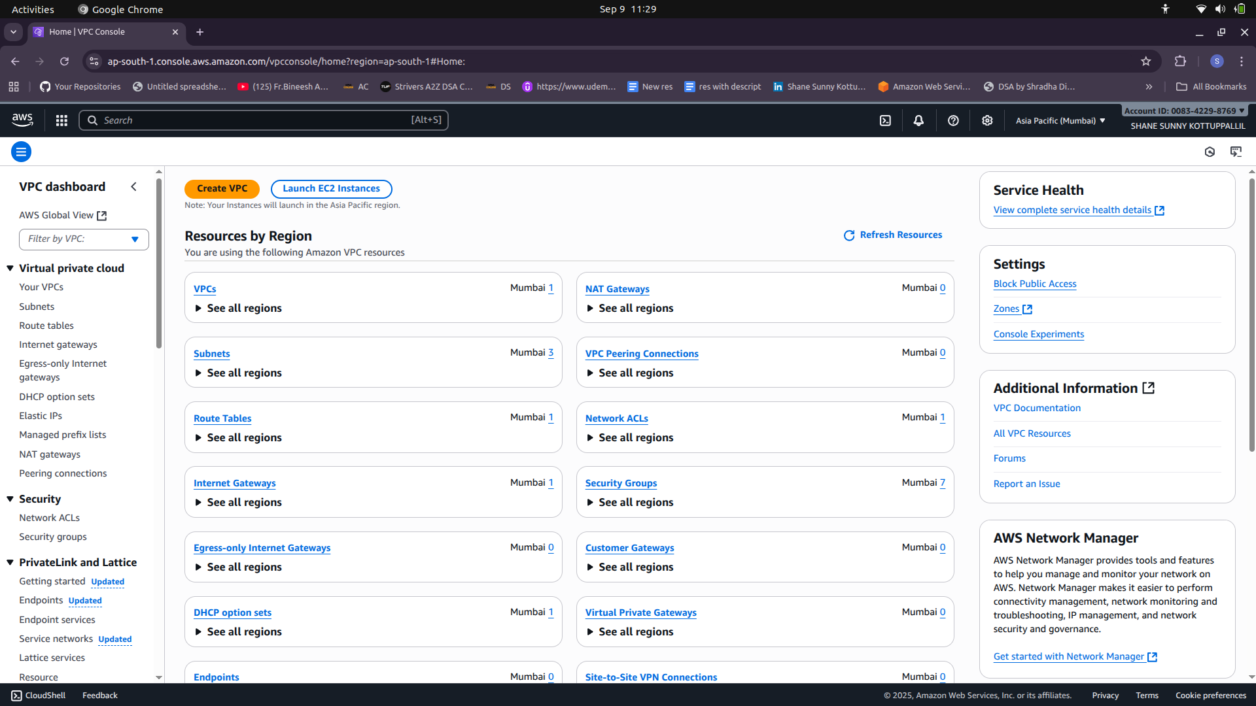

VPC CIDR : 10.0.0.0/24

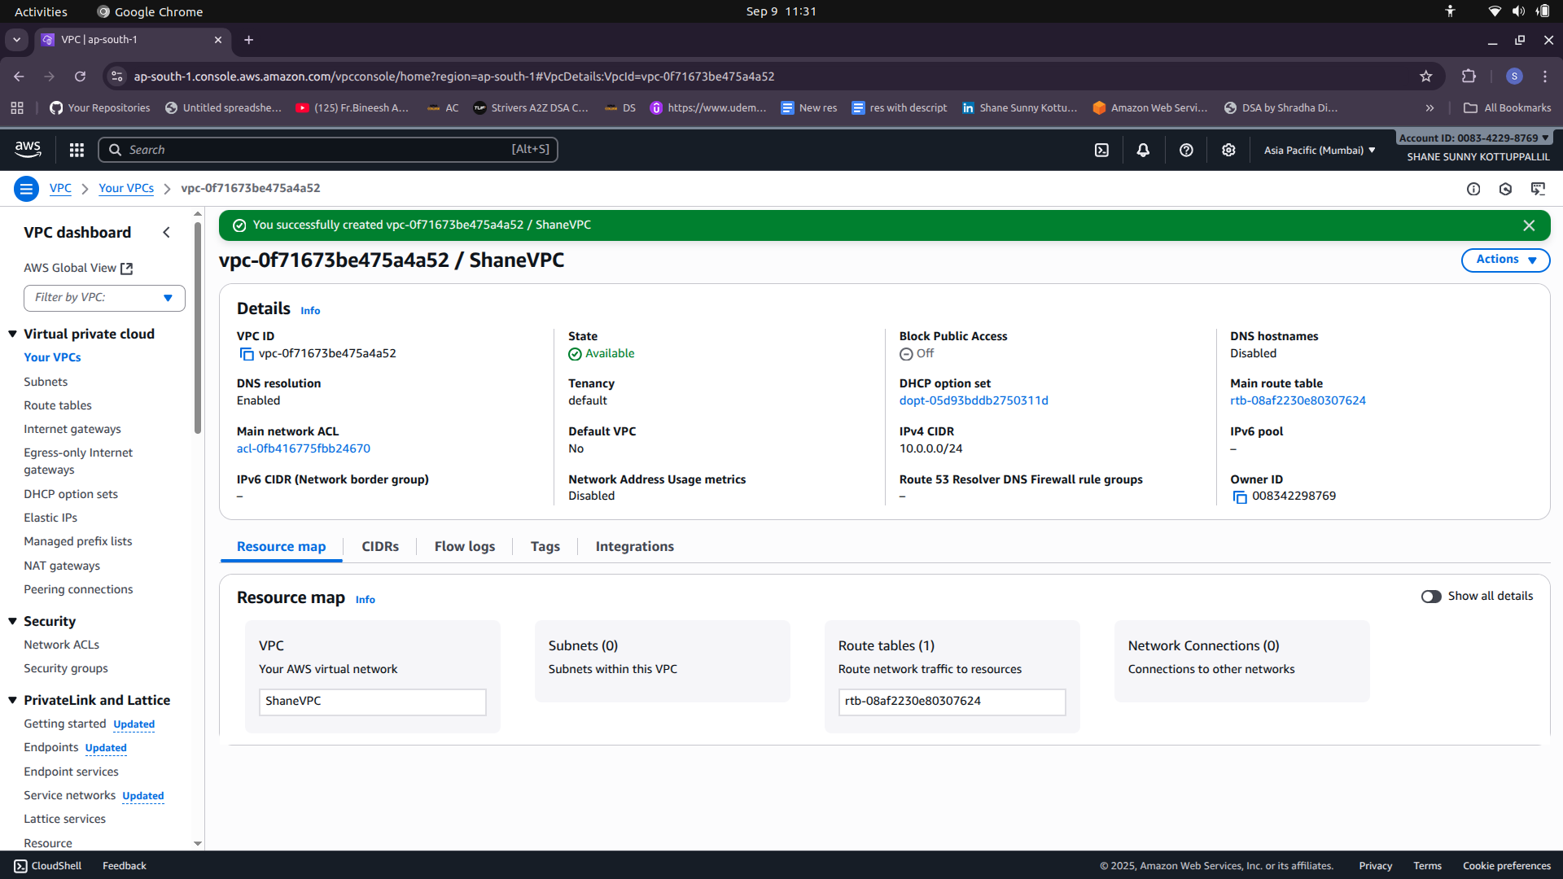

**Subnetting**

Subnets on 3 Different Azs

1) Availability Zone A

Private Subnet A (25 hosts)

Public Subnet A (55 hosts)

2) Availability Zone B

Private Subnet B (55 hosts)

Public Subnet B (25 hosts)

3) Availability Zone C

Private Subnet C (25 hosts)

Public Subnet C (25 hosts)

Subnetting VLSM (Variable Length Subnet Masking)

VPC CIDR 10.0.0.0/24

Subnet Mask 255.255.255.0

Maximum Number of Hosts = 256

Public A (55 Hosts)

Host bits =6

/26

SM = 255.255.255.192

BS = 256-192 =64

10.0.0.0/26 – 10.0.0.63/26

Private B (55 Hosts)

10.0.0.64/26 – 10.0.0.127/26

Private A (25 Hosts)

Host bits = 5

/27

SM = 255.255.255.224

BS = 32

10.0.0.128/27 – 10.0.0.159/27

Public B (25 Hosts)

10.0.0.160/27 – 10.0.0.191/27

Private C (25 Hosts)

10.0.0.192/27 – 10.0.0.223/27

Public C (25 Hosts)

10.0.0.224/27 – 10.0.0.255/27

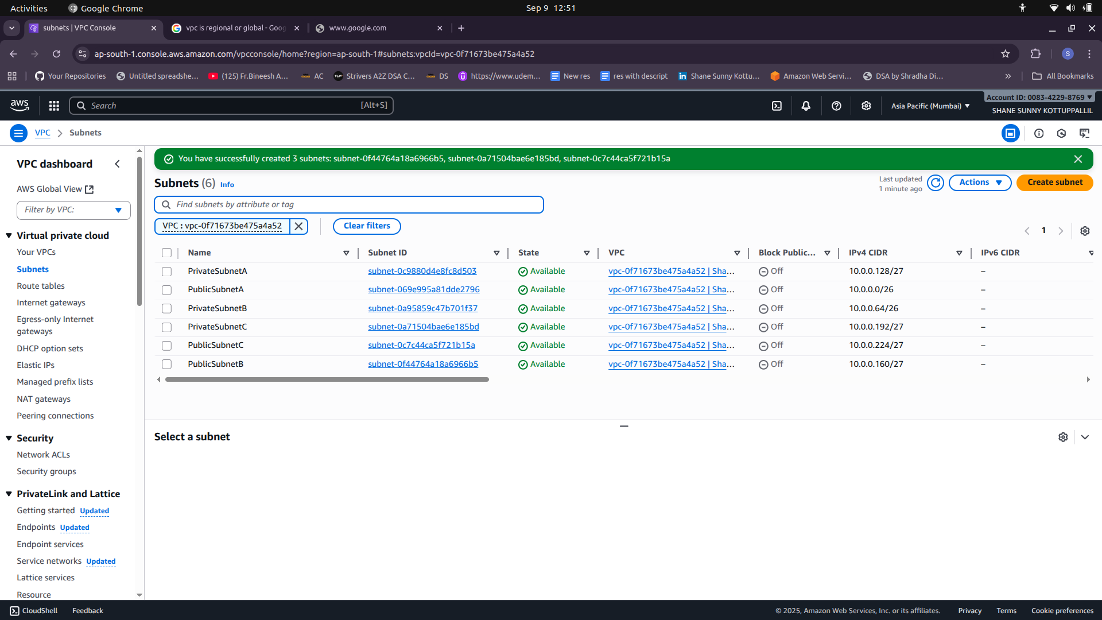

**Internet Gateway (IGW)**

- one per vpc is allowed

ShaneVPC-igw

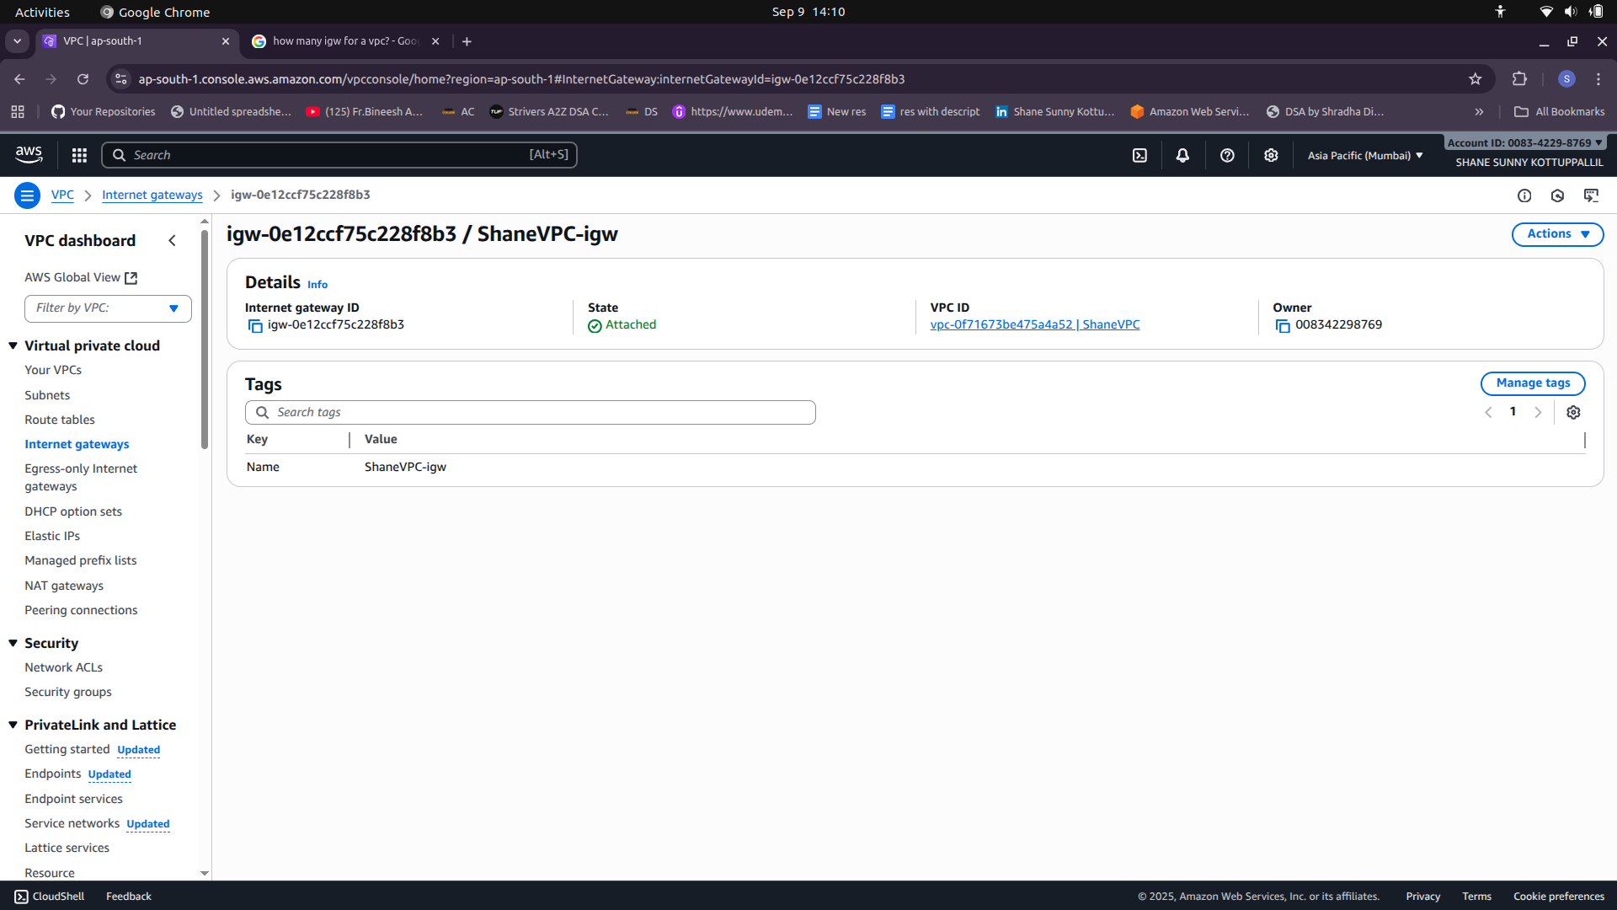

Route Tables

1) Route Table for Public Subnet

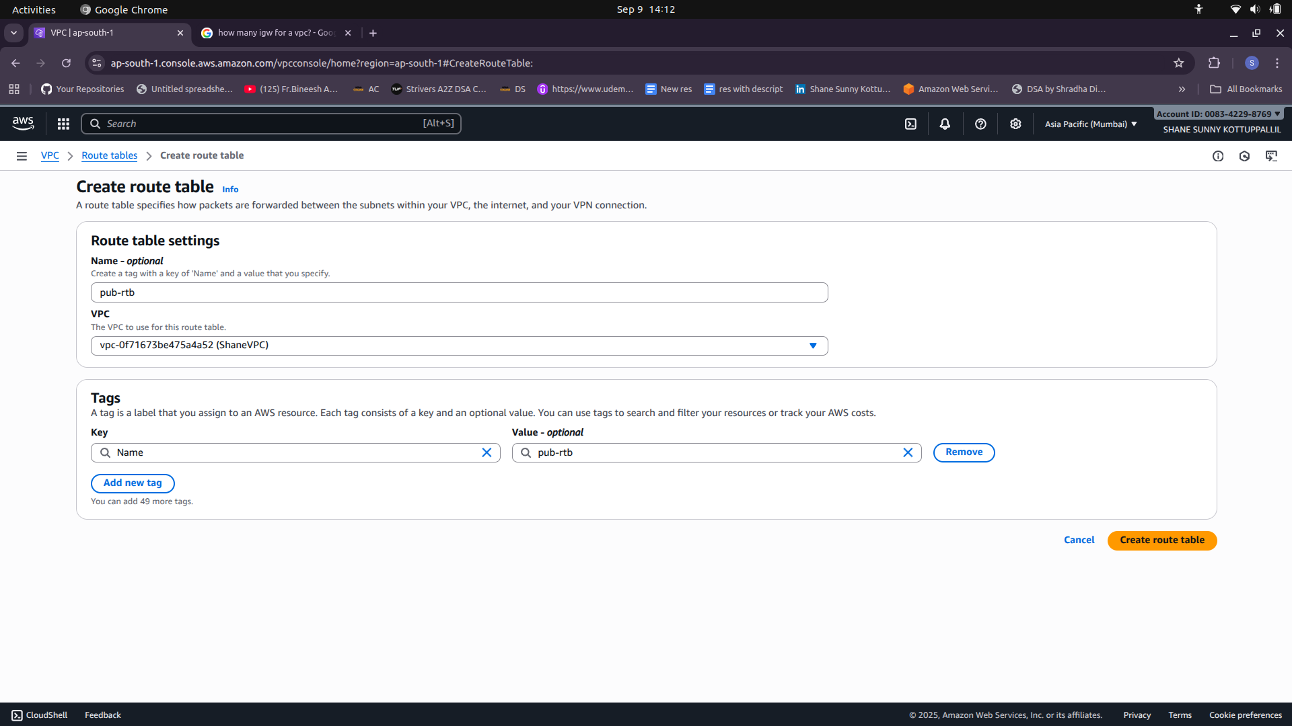

Public Subnet Associations and Edit Routes (To give IGW Route)

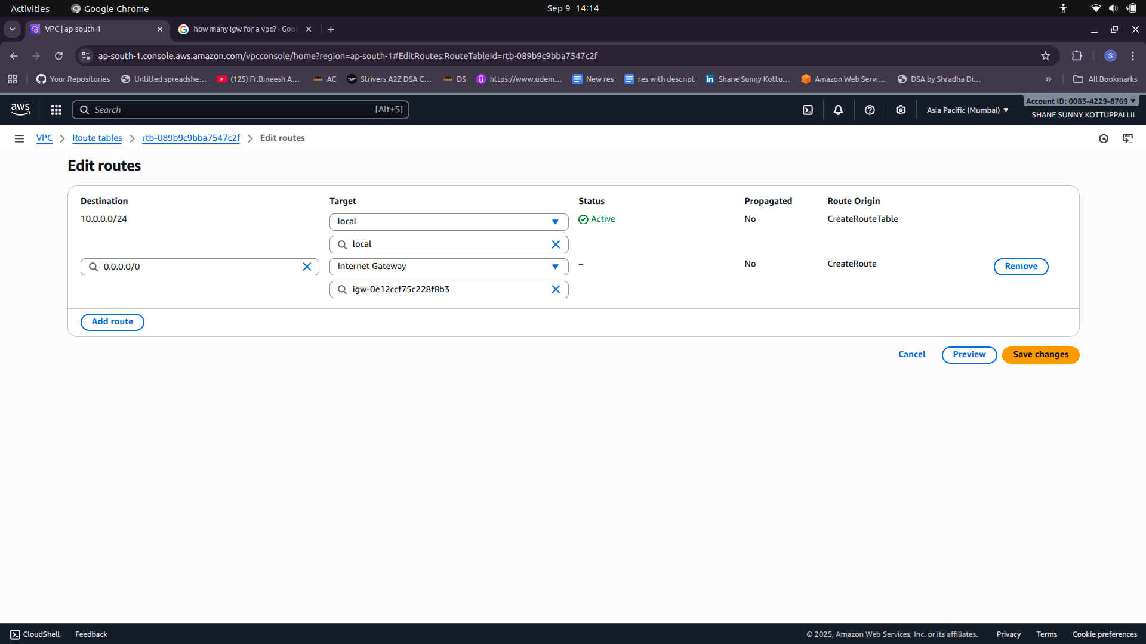

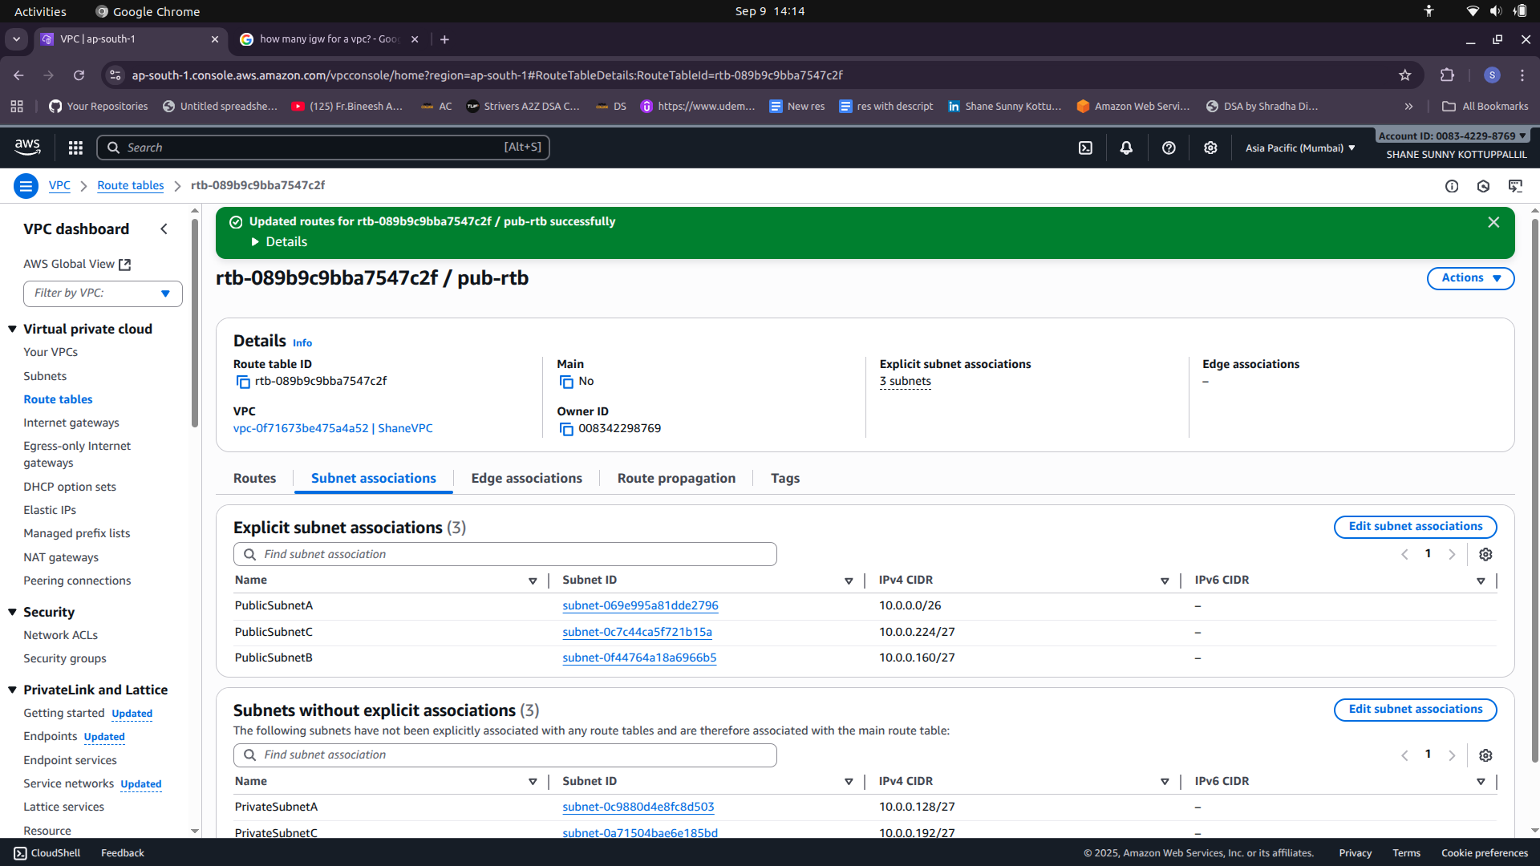

**Bastion Hosts**

1) Create Bastion Host (EC2 Instance) on Public Subnet with SSH access.

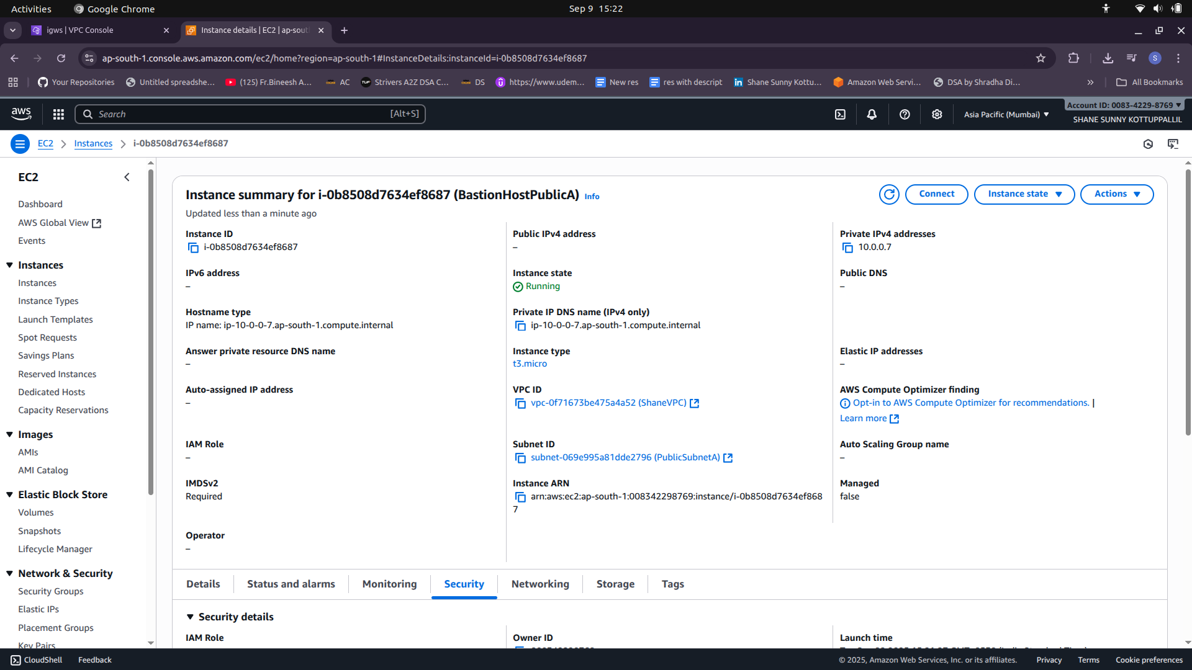

2)Create Private EC2 Instance on Private Subnet

-Allow SSH access only from Bastion Host’s Private IP.

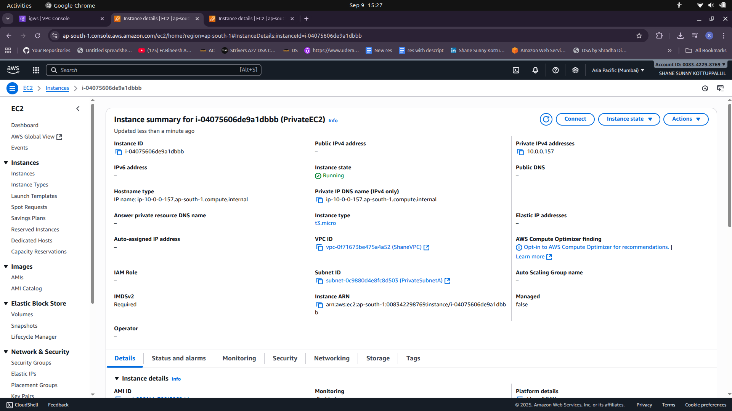

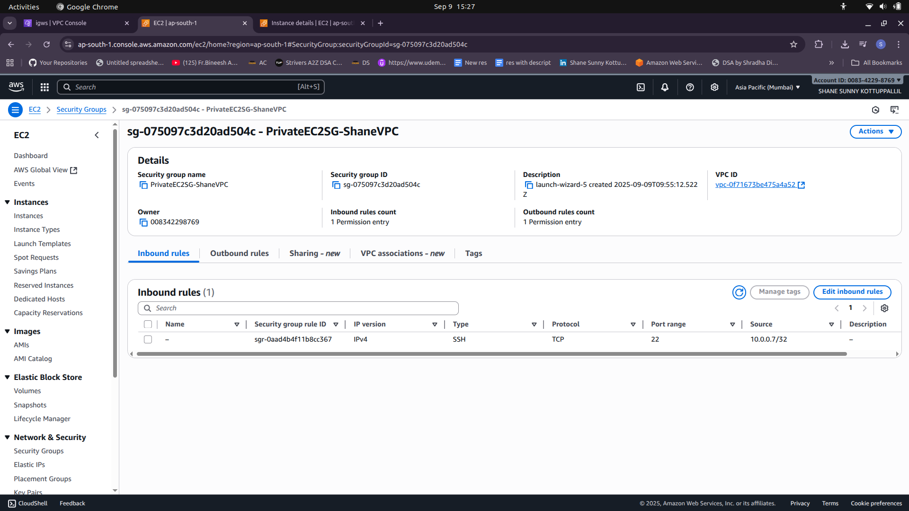

- Copy key pair on private instance and change permission of the pem file

vi Keypair.pem

chmod 400 Keypair.pem

ssh i Keypair.pem [ec2user@private](mailto:ec2user@private)IPBastion

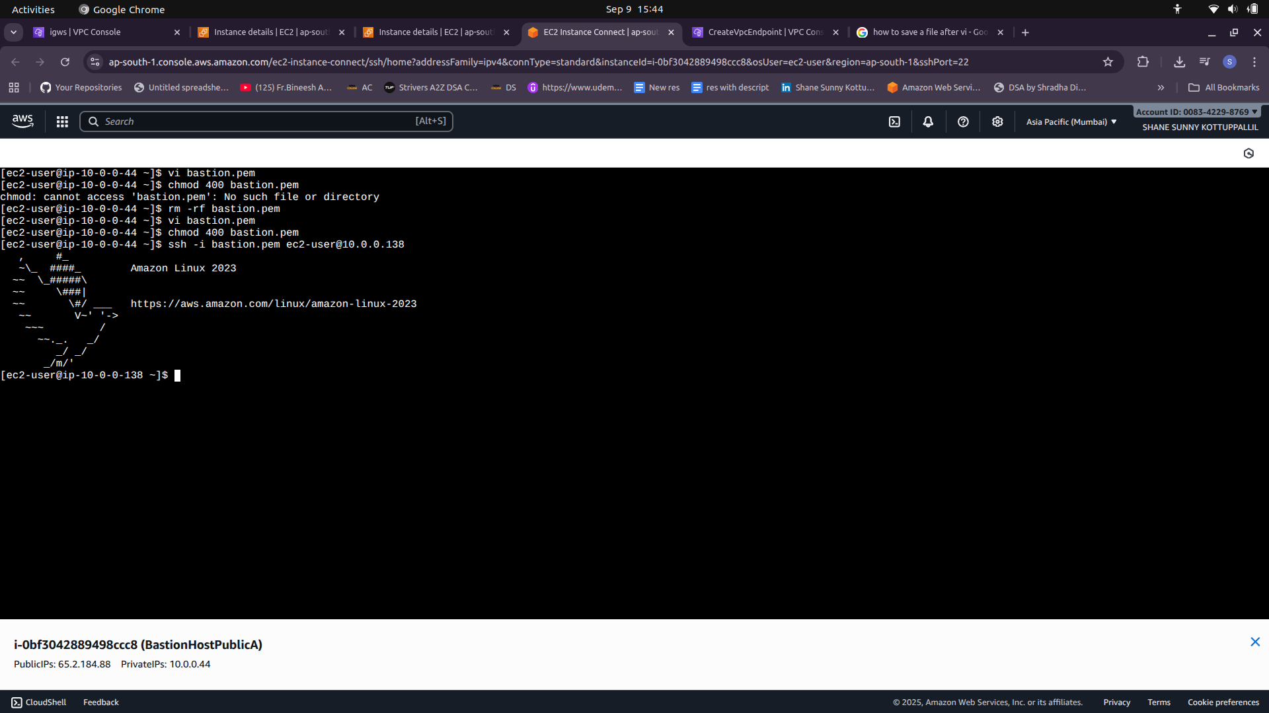

**NAT Gateway**

1) Create NAT Gateway and assign Elastic IP to it.

2) Router with Private subnet associations

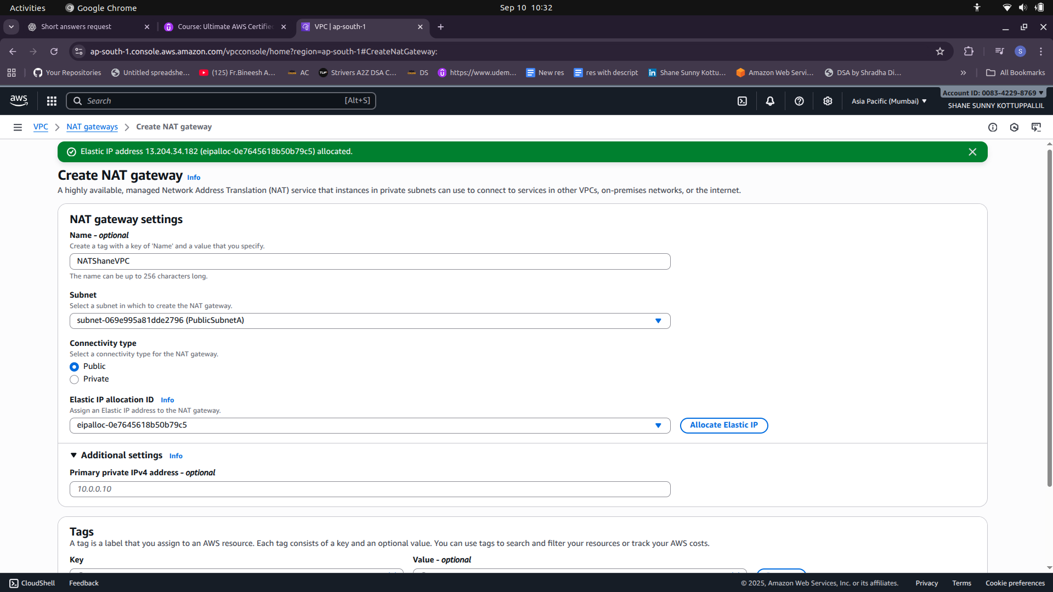

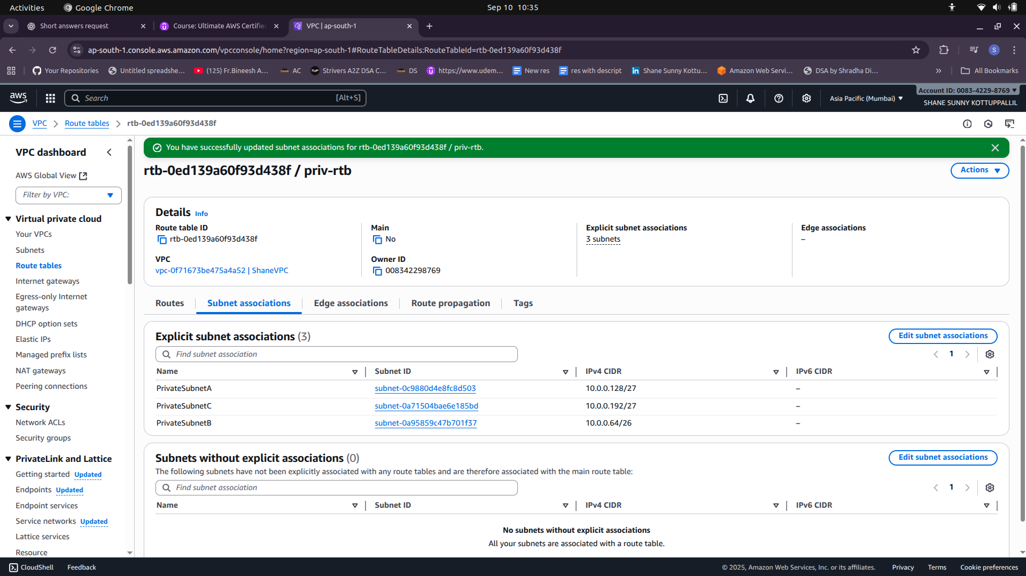

3) Create Route for NAT Gateway

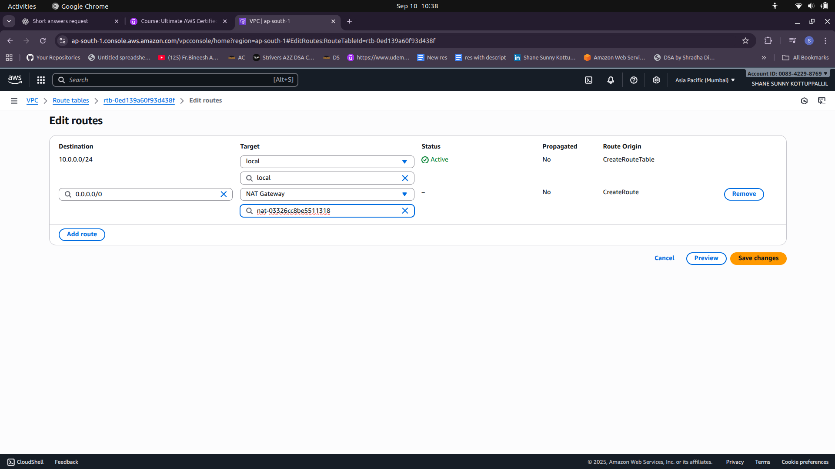

4) Verify if EC2 Instance in Private Subnet has Internet access.

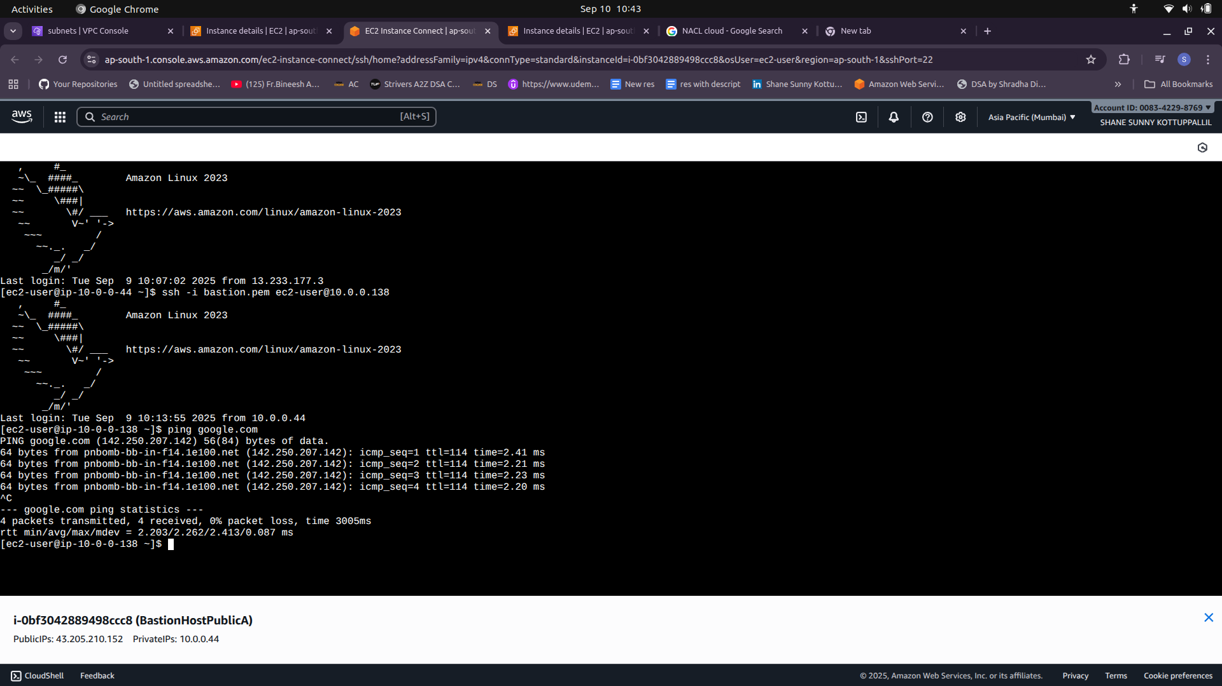

**VPC Peering**

1) Create VPC Peering (Peering Connections)

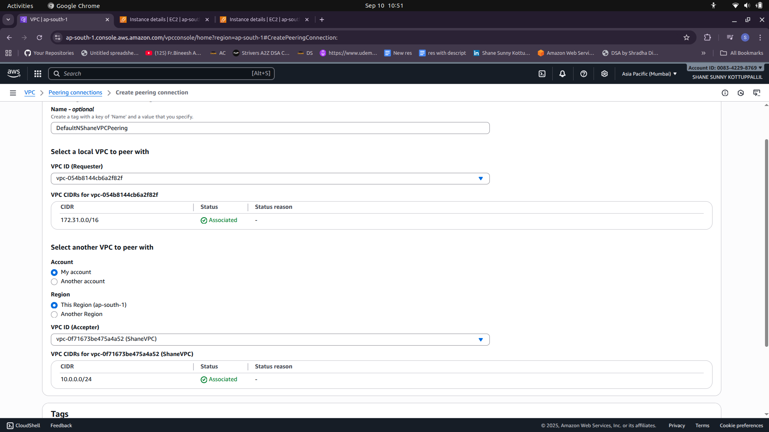

2) Accept Peering Connection Request

3) Edit Route Table

